

PORT NOTICE TO MARINERS
No 06 of 2026
28/04/2026
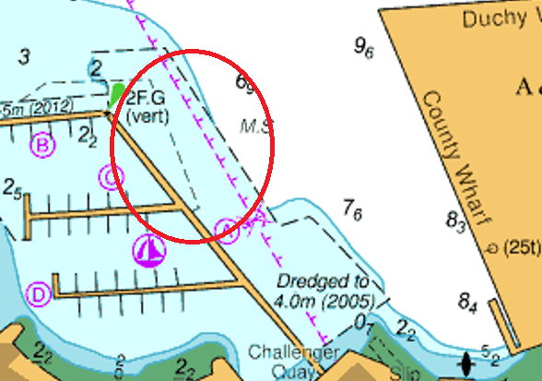
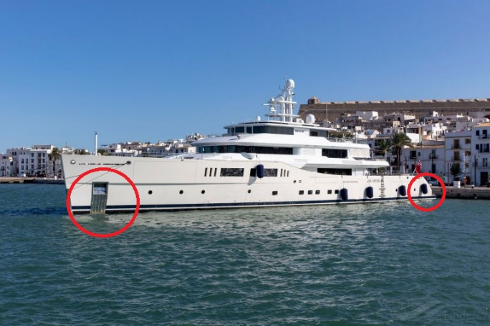
Notice is hereby given that due to the forecasted strong easterly winds, MY Nautilus berthed alongside Pendennis Marina has deployed a bow and stern anchor outward from the Port side of the vessel.

BOW Anchor Position 50’9.2186N / 005’3.6446W
STERN Anchor Position: 50’9.14336N / 005’3.6030W

Mariners are requested to proceed with caution in this area.

Port Pendennis Marina are contactable on VHF 80, by calling 01326 211211 or emailing marina@portpendennis.com

This notice is self-cancelling on recovery of the anchor.

Tim Sykes
Port Operations Manager
Falmouth Docks and Engineering Company
MOM@AP-Group.co.uk
01326 214666

